Spring Core Maven  
  
  
**Exercise 1: Configuring a Basic Spring Application**  
  
package com.example.repository;

public class BookRepository {

public BookRepository() {

System.out.println("This is BookRepository");

}

}  
  
package com.example.service;

public class BookService {

public BookService() {

System.out.println("This is BookService");

}

}

**Exercise 2: Implementing Dependency Injection**  
  
package com.example.repository;

public class BookRepository {

public BookRepository() {

System.out.println("BookRepository Created");

}

@Override

public String toString(){

return "BookRepository Injected";

}

}  
  
  
package com.example;

import com.example.service.BookService;

import org.springframework.context.ApplicationContext;

import org.springframework.context.support.ClassPathXmlApplicationContext;

/**

* Hello world!

*

*/

public class App

{

public static void main( String[] args )

{

System.out.println("Application Started");

ApplicationContext context = new ClassPathXmlApplicationContext("applicationContext.xml");

BookService service = context.getBean(BookService.class);

service.printBookRepository();

}

}

**Exercise 4: Creating and Configuring a Maven Project**  
  
package com.example;

import junit.framework.Test;

import junit.framework.TestCase;

import junit.framework.TestSuite;

public class AppTest

extends TestCase

{

/**

* Create the test case

*

* @param testName name of the test case

*/

public AppTest( String testName )

{

super( testName );

}

/**

* @return the suite of tests being tested

*/

public static Test suite()

{

return new TestSuite( AppTest.class );

}

/**

* Rigourous Test :-)

*/

public void testApp()

{

assertTrue( true );

}

}  
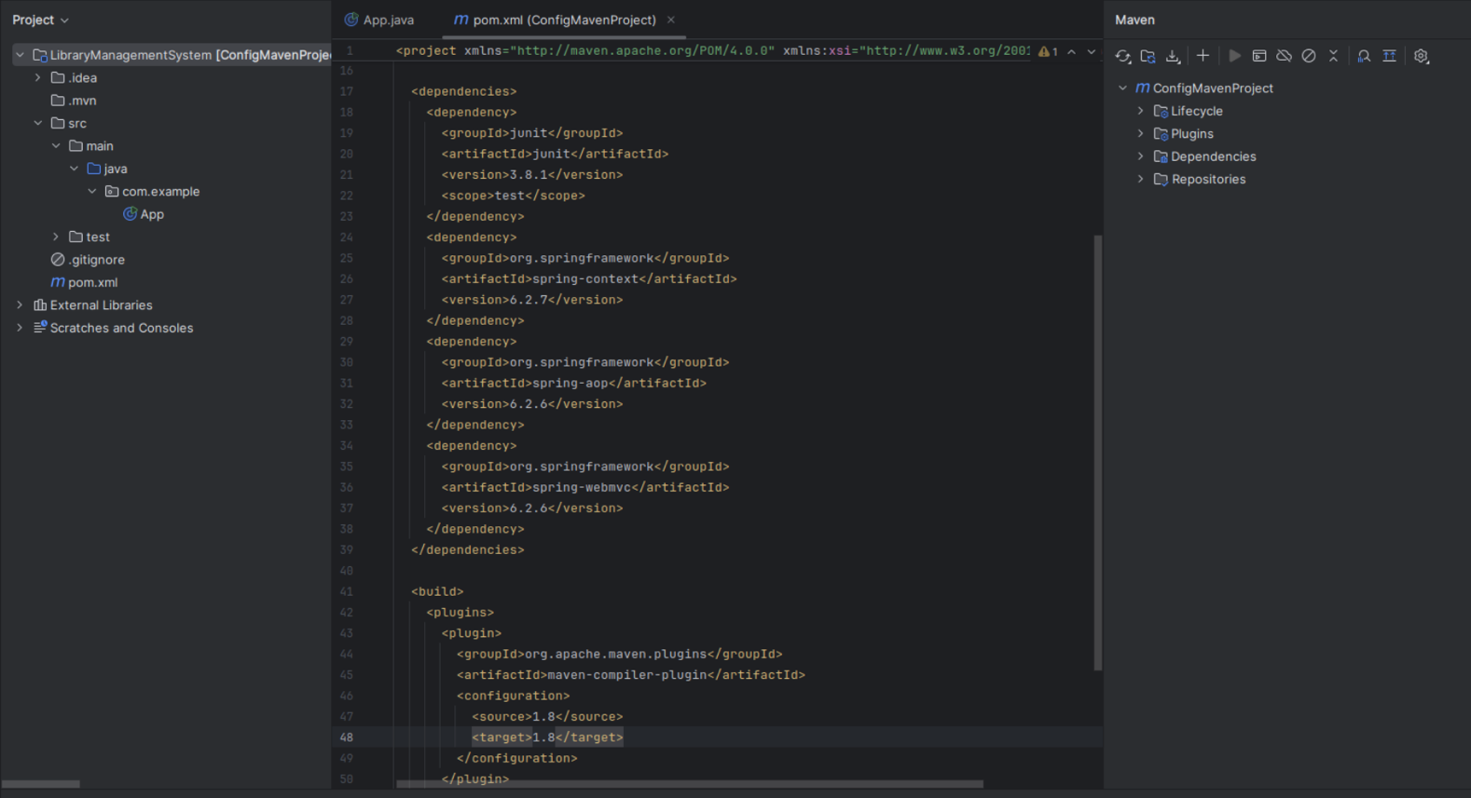  
  
**Exercise 5: Configuring the Spring IoC Container**  
  
package com.example.repository;

import java.util.Arrays;

import java.util.List;

public class BookRepository {

public BookRepository() {

System.out.println("BookRepository Created");

}

public List<String> getBooks() {

return Arrays.asList("Java Books", "Spring Books", "Mern Books");

}

}

**Exercise 7: Implementing Constructor and Setter Injection**  
  
package com.example;

import com.example.service.BookService;

import org.springframework.context.ApplicationContext;

import org.springframework.context.support.ClassPathXmlApplicationContext;

public class App

{

public static void main( String[] args )

{

ApplicationContext context = new ClassPathXmlApplicationContext("applicationContext.xml");

BookService bookService = context.getBean(BookService.class);

System.out.println(bookService.getLibraryName());

bookService.getBooks();

}

}

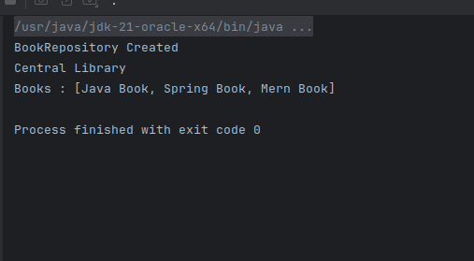  
  
**Exercise 9: Creating a Spring Boot Application**  
